1、架构信息
 | X86 | RISC-V
内核版本 | Linux sophgo-Rack-Server 6.8.0-90-generic #91~22.04.1-Ubuntu SMP PREEMPT_DYNAMIC Thu Nov 20 15:20:45 UTC 2 x86_64 x86_64 x86_64 GNU/Linux | Linux openeuler-riscv64 6.12.56-0.0.0.0.riscv64 #1 SMP Fri Oct 31 03:04:33 CST 2025 riscv64 riscv64 riscv64 GNU/Linux
lscpu | 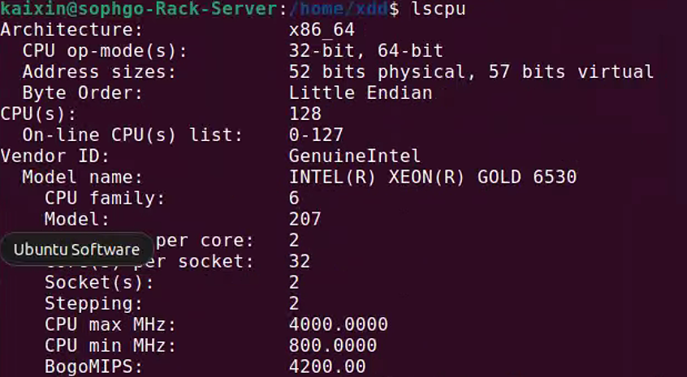  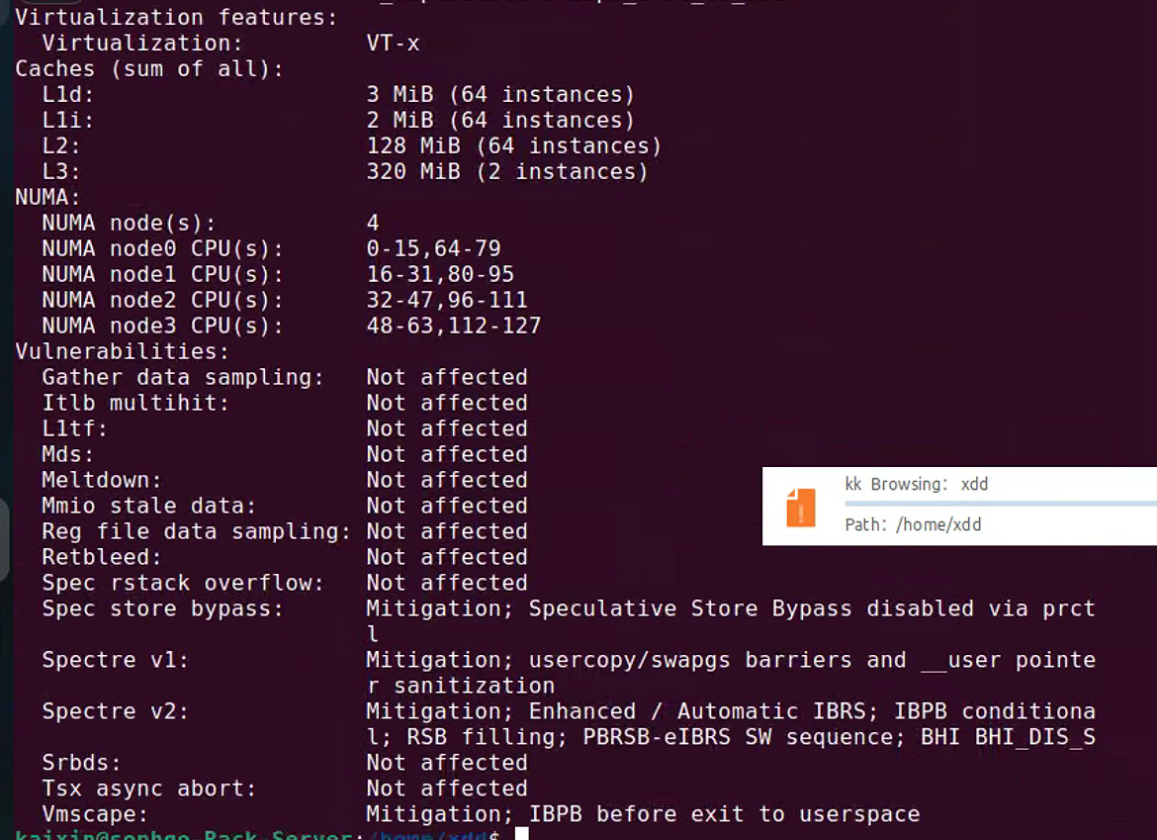 | 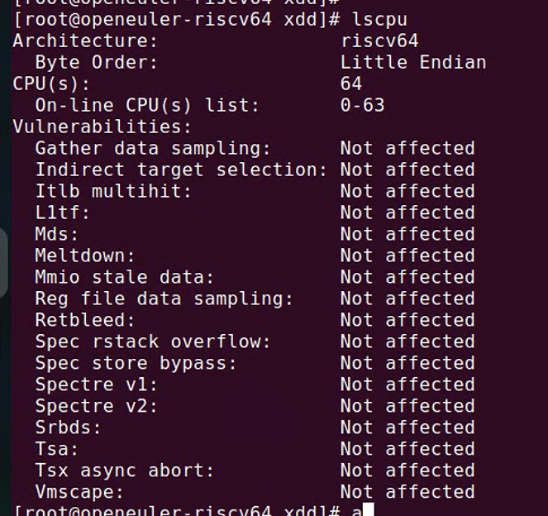
cat /sys/devices/system  /cpu/cpu*/cpufreq/scaling_cur_freq | 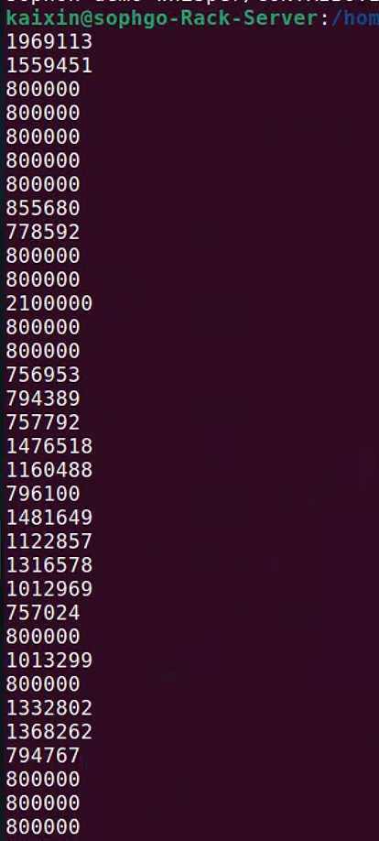 | 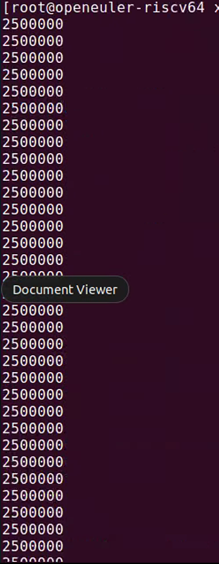
内核时间配置：  grep -E  "NO_HZ|HPET|TSC" /boot/config-$(uname -r) | CONFIG_NO_HZ_COMMON=y  # CONFIG_NO_HZ_IDLE is not set  CONFIG_NO_HZ_FULL=y  CONFIG_NO_HZ=y  CONFIG_X86_TSC=y  CONFIG_HPET_TIMER=y  CONFIG_HPET_EMULATE_RTC=y  CONFIG_TOUCHSCREEN_USB_DMC_TSC10=y  CONFIG_TOUCHSCREEN_TSC_SERIO=m  CONFIG_TOUCHSCREEN_TSC200X_CORE=m  CONFIG_TOUCHSCREEN_TSC2004=m  CONFIG_TOUCHSCREEN_TSC2005=m  CONFIG_TOUCHSCREEN_TSC2007=m  CONFIG_TOUCHSCREEN_TSC2007_IIO=y  CONFIG_HPET=y  CONFIG_HPET_MMAP=y  CONFIG_HPET_MMAP_DEFAULT=y  # ATSC (North American/Korean Terrestrial/Cable DTV) frontends  CONFIG_SND_SOC_TSCS42XX=m  CONFIG_SND_SOC_TSCS454=m  CONFIG_TI_TSC2046=m | CONFIG_NO_HZ_COMMON=y  # CONFIG_NO_HZ_IDLE is not set  CONFIG_NO_HZ_FULL=y  CONFIG_NO_HZ=y  # CONFIG_TOUCHSCREEN_IMX6UL_TSC is not set  CONFIG_TOUCHSCREEN_USB_DMC_TSC10=y  # CONFIG_TOUCHSCREEN_TSC_SERIO is not set  # CONFIG_TOUCHSCREEN_TSC2004 is not set  # CONFIG_TOUCHSCREEN_TSC2005 is not set  CONFIG_TOUCHSCREEN_TSC2007=m  CONFIG_TOUCHSCREEN_TSC2007_IIO=y  # ATSC (North American/Korean Terrestrial/Cable DTV) frontends  CONFIG_SND_SOC_TSCS42XX=m  # CONFIG_SND_SOC_TSCS454 is not set  CONFIG_TI_TSC2046=m

2、coremark测试
